Dover Area Historical Society

Presents

Happy 110th Birthday, Dorothy!

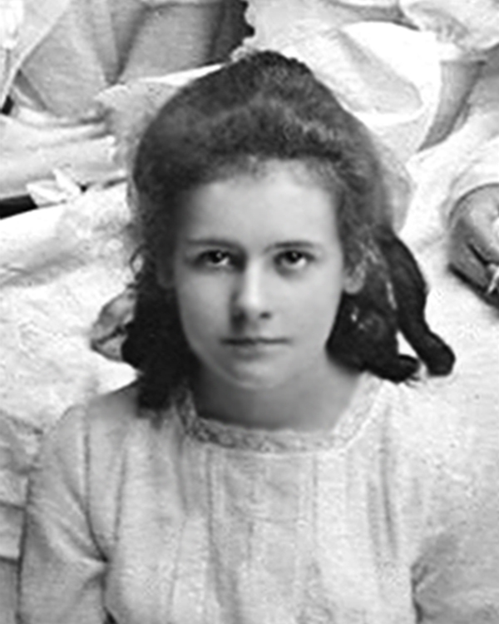

Our Sixth Annual Afternoon Tea
Saturday, September 28, 2013

Dover Area Historical Society Museum House
55 W. Blackwell Street
P.O. Box 609
Dover, NJ 07802
(973) 361-3525

www.doverhistoricalsociety.com
W E L C O M E TO OUR MUSEUM

We are pleased to have friends and supporters join us for our sixth annual afternoon tea. This year the Dover Area Historical Society is celebrating two important milestones. As you can tell from the decorations, we’re celebrating the birthday of our resident ghost, Dorothy, who would have been 110 years old this year on November 28. You will learn more about Dorothy, her family and this historic house in the following few pages. In addition, ten years ago this fall, D.A.H.S. leased this building from the First Memorial Presbyterian Church. It took a great deal of work from many members and community volunteers to transform the building into the museum you see today. The restoration work continues and we celebrate all that has been accomplished in the past ten years.

Proceeds from this fundraiser will benefit the restoration and maintenance of the museum house, and a portion will be donated to the D.A.H.S. scholarship fund.

It is a pleasure to see some familiar faces at our tea each year and to welcome new guests. As many of you know, spaces fill up fast. If you hope to attend next year, please see Phyllis before you leave to make an advance reservation for next year. Tickets will go on sale in early August 2014.

Thank you for joining us. Please feel free to browse and enjoy the photographs or to join us for one of our monthly meetings here at the museum house on the third Tuesday of each month, beginning at 7:30 P.M. New members and visitors are always welcome.

Menu

A selection of caffeinated and decaf teas

Sandwiches

Alan’s cucumber rounds
Alice’s ham and cheese on potato rolls
Betty’s famous egg salad sandwiches
Cathie’s tuna salad sandwiches
Kathi’s favorite scones, cream and strawberry preserves
Linda’s turkey sandwiches

Desserts/Sweets

Bonnie’s birthday cupcakes
Brenda’s lemon drops
Brenda’s pecan pie bars
Flavia’s oatmeal cookies
Helen’s candy treats
Phyllis’ date and nut bread with cream cheese


The D.A.H.S. Museum House and Its Inhabitants

The building which now serves as the museum house was built by Dr. Arthur W. and Caroline Condict in 1890 and the family lived here until the early 1920’s. The Condict family included four daughters: Mary Carroll, born June 8, 1891; Rachel Hall, born November 17, 1893; Lucy Coe, born October 14, 1895; and Dorothy Gertrude, born November 28, 1903. The girls all graduated from Dover High School between 1911 and 1921. Dr. Condict’s medical offices were on the first floor and the family resided on the second and third floors.

After graduating from Dover High School in 1921, Dorothy Condict attended Trenton Normal School. She worked as an occupational therapist at the New Jersey State Hospital in Morris Plains (Greystone). On September 17, 1927, she married Russell Rogers and in 1930 the couple moved to a home on Burnham Road in Morris Township. Dorothy and Russell moved to Addison, Vermont in 1951. Dorothy died in Addison, VT in December 2000 at the age of 97. Her daughter, Judith Louise Rogers presently lives in Vergennes, Vermont.

Over the years, the historical society has learned a great deal about Dorothy! Many felt her “presence” while work crews were renovating the museum. Several strange occurrences could not be explained: the smell of perfume when no source of the scent could be found; the light brushes of someone passing, when no one was there; thumping noises in various parts of the house; and most recently, the ringing of a bell on the first floor mantle when the only two people in the house were on the second floor.

The story of Dorothy began to unravel when a work crew from Dover’s Masonic Lodge discovered a bundle of approximately 30 love letters which were nearly 100 years old. These letters were written to Dorothy by several admirers. They had been stashed under the floor boards in Dorothy’s third floor bedroom and crashed through the ceiling to land in the sitting room on the second floor. Two years ago, while repairing a leak into the back stairway, a plumber broke through the plaster and found additional items assumed to have been stashed by Dorothy, including a tea set and baseball cards. When school groups visit, the students often excitedly dash up to the third floor to see if Dorothy will make an appearance.

After the Condict family left the house, Dr. Costello and his family inhabited the house, and later, the family of Dr. Joseph and Sylvia Shanik lived in the house. Dr. Shanik’s medical offices were on the first floor and the family, which included three daughters, lived on the second and third floors. The parking lot behind the house was a grassy area and the girls enjoyed playing there. Dr. Shanik sold the house to the First Memorial Presbyterian Church in 1963 for $1.00. Mrs. Shanik and two of her daughters attended our first afternoon tea in 2008, and one of their daughters is joining us this year. Mrs. Shanik passed away a few years ago. All three daughters are still in contact with D.A.H.S members.

Sources:
“The Condict Girls,” Dover Area Historical Society

Daily Record, October 6, 2010, written by Matt Manochio, Staff Writer, based on interviews with the Dover Area Historical Society.


Upcoming Events:
Tuesday, October 15: “War of the World Radio Show” 7:30 PM at the Museum House. Listen to the greatest radio hoax in history, broadcast over antique radios. No charge. Refreshments will be served. Annual business meeting will follow the program.

Friday, October 18: “The History of the Dover Speedway” with Bob Wagner. 7:00 PM, Dover High School auditorium, 100 Grace Street, Dover. One of the greatest stories in local raceway history, from horse racing in the late 1800’s to its disastrous closing after the collapse of the grandstands in the 1950’s during auto racing. The speedway was located on Route 46 in the space which is now Shop Rite, Rockaway and the surrounding parking lot. Speedway memorabilia will be on sale at the event. $5.00 donation requested.

Tuesday, November 19: “The Northside School – The Later Years” 7:30 PM at the Museum House. No charge. Refreshments will be served.

Tuesday, December 17: “Holiday Open House” 4:00-9:00 PM at the Museum House. Come and join friends and supporters of the historical society. Holiday cheer and plenty of treats. Please bring
a donation or small gift for the museum house (cleaning supplies, maintenance items, etc.) Refreshments will be served.

For information about any of the events listed above call 973 361-3525 or visit our website, www.doverhistoricalsociety.com.

DAHS Afternoon Tea Committee

Co-chairs: Phyllis Casey, Kathi Gilbert, and Alice Wagner

Committee members: Joan Bocchino, Jane Curtin, Bonnie Daboney, Jeanne Bishop DeMark, Betty Inglis, Linda
Mullin, Brenda Woodhull, Cathie Van Orden

The Afternoon Tea Committee would like to thank all the generous people who donated their time, talent, services and door prizes.

Dover High School Key Club ………...………………………………..…….Set up, movers, servers
Boy Scout Troop #64……………………………….……………………….………….Room set up, movers
Joan Bocchino……………………………………...……Design and Printing of Tickets and Flyers
Phyllis Casey……………………………………………..….………………..Reservations and Ticket Sales
Kathi Gilbert………………………………….…..………..…..……… Programs and Tea Ladies Posters
George Laurie …………………………………….…………………………………………..………………Audio/Music
Rick Kelly……………………………………………………………………………………….………………….Photography
Lillian Vega…………...........................................................................Chair covers and sashes
First Memorial Presbyterian Church ………………….……………….……………..……Parking Area
Joanne Swayze………………………………………………………………….…………..……………..Housekeeping
Scott Miller and Boy Scout Troop 64…………………………………..…….……….…..…Landscaping
George Laurie and Bob Van Orden………..…………….………….……Event Special Assistants
DAHS “Men of Steel”…………….…........Carpentry, painting, furniture moving, etc.
Bakers/Cooks/Food …. Alan Bocchino, Flavia Brock, Phyllis Casey, Bonnie Daboney, Kathi Gilbert, Betty Inglis, Linda Mullin, Helen Pennella, Cathie Van Orden, Alice Wagner, and Brenda Woodhull
Servers and Greeters…….Eve Casey, Jane Curtin, Jeanne Bishop DeMark, Linda Romeo, and Carole Forbes Walker

Special thanks to Carolyn in the Walmart Photo Department for her patience and talent in scanning, enhancing and printing some very old photos; and to Rick Kelly for his technical support with photographs.

Donations and Door Prizes (as of September 18, 2013): Carolyn Bishop, Joan Bocchino, Eve Casey, Phyllis Casey, Costco Wholesale of Wharton, Bonnie Daboney, Dover Area Historical Society, Kathi Gilbert, Linda Mullin, Dorothy Roff, Diane Saitta, Stan Schoonmaker, Shop Rite – Rockaway/Dover, Ginny Shukailo, Alice Wagner, Mary Ann Waldek, and Brenda Woodhull

