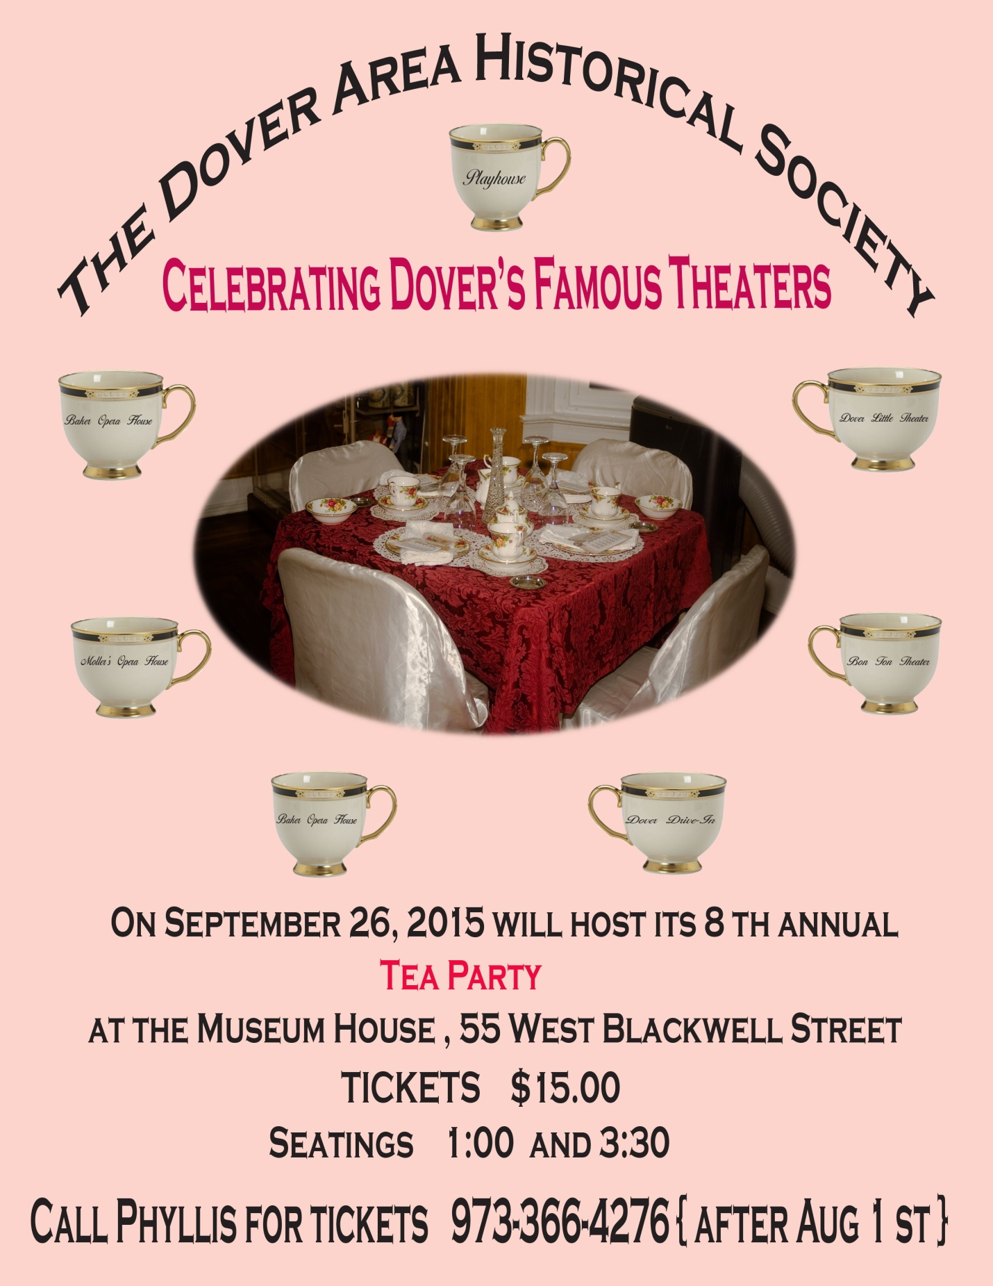

WELCOME TO OUR MUSEUM

We are pleased to have friends and supporters join us for our eighth annual afternoon tea. This year the Dover Area Historical Society is “Celebrating Dover’s Famous Theaters”.

Proceeds from this fundraiser will benefit the restoration and maintenance of the museum house, and a portion will be donated to the D.A.H.S. scholarship fund.

It is a pleasure to see some familiar faces at our tea each year and to welcome new guests. As many of you know, spaces fill up fast. If you hope to attend next year, please see Phyllis before you leave to make an advance reservation. Tickets will go on sale in early August 2016.

Thank you for joining us. Please feel free to browse and enjoy the photographs or to join us for one of our activities at the Museum House. New members and visitors are always welcome.

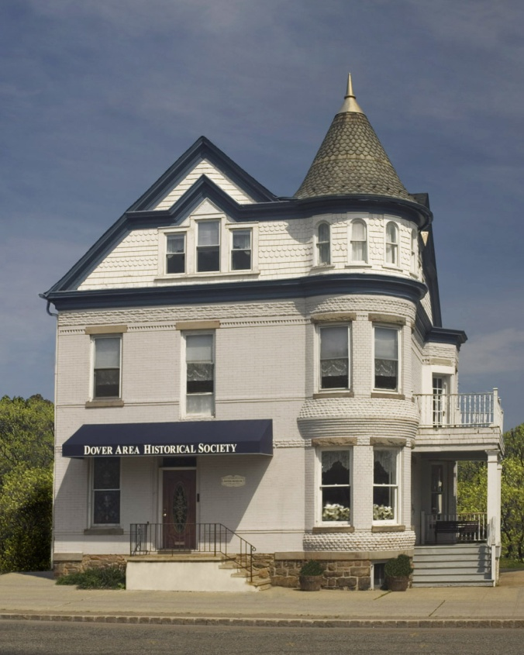

Menu
A selection of caffeinated and decaffeinated teas

Sandwiches

Alan’s cucumber rounds
Alice’s ham and cheese on potato rolls
Linda’s turkey ranch wraps
Linda’s chicken salad with walnuts and cranberry croissants
Brenda’s “King Arthur’s Scones”

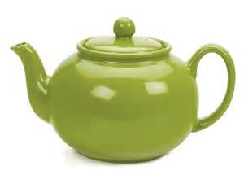

Desserts/Sweets

Betty’s creamy puffs
Bishop’s brownies
Alan’s lemon thins
Helen’s snowy snowballs
Phyllis’ date and nut bread with cream cheese

Celebrating Dover’s Famous Theaters
The historical information for our program was researched by our late friend and DAHS Museum Curator, George C. Laurie.

The Moller Opera House
c. 1850-1921
16 North Sussex Street
Construction: 1850-1860
Architect style: Franco-Italianate commercial vernacular, three stories. Opera House auditorium survives in altered form. One of only a few “freestanding” buildings in Dover’s Historic District
(Robert Guter/Dover Redevelopment Agency)

The Moller Opera House and Saloon was perhaps Dover’s first large establishment for major “live” entertainment. Owned and operated by Daniel Moller, the Moller Opera House was located along the busy Morris Canal on North Sussex Street “next to the canal bridge”. The music hall/saloon was constructed sometime between 1850 and 1860, long before the Baker Opera House and Baker Theater ever existed. It has also been referred to as “Moller’s Opera House and Symphony Hall”.

Canal boatmen patronized Moller’s during their weekend stopovers in Dover and enjoyed the beverages and entertainment the playhouse had to offer. That entertainment at the time was in the form of burlesque and minstrel shows, the forerunners to vaudeville. Workers from the nearby mines and factories made Moller’s a very busy popular establishment in its day.

Burlesque shows began to transform into broader forms of entertainment and by 1865, modern vaudeville was developed which would now appeal more to a family audience. Vaudeville was a collection of variety acts featuring comedy sketches and short plays with music, often featuring leading actors and actresses. By the late 1800’s, vaudeville became the most popular form of entertainment not only in Dover, but around the country.

Dover’s first Fireman’s Ball was held in 1873 at the Moller Opera House. By the 1880’s, the “big time” vaudeville acts and programs existed in the larger cities. Soon producers and mangers created traveling “road shows”. A national railroad system was developed around this time so traveling shows became more feasible. William H. Baker, a wealthy mine baron and Dover civic leader, decided to “squeeze-in” on Moller’s business and constructed a new vaudeville playhouse, the Baker Opera House, in 1885. The new venue site was close to the train station. This put Dover on the traveling show circuit.

After the Baker Opera House opened on April 3, 1886, the Moller Opera House no longer operated as a major playhouse, but as a saloon and entertainment center. Popular songs of the day and sing-alongs remained the main attraction at Moller’s for many more years as the major entertainment moved to the Baker Opera House.

Moller’s closed forever on January 16, 1920 when the National Prohibition Act (18th Amendment) went into effect. The billiards, pool and bowling alley continued to operate, while the second floor became the leading amusement hall in town and the scene of many local events. This room had been a drill hall in World War I. Herman Moller sold the building to the National Biscuit Company in January, 1921.

The building today is occupied by Dover’s longest continuous business, Goodale’s Drug Store, founded in 1850 by William H. Goodale.

The Baker Opera House
1886-1904
The Baker Building
Southeast corner of Blackwell and Warren Streets
Construction date: 1885-1886
Architect style: eclectic, three stories plus a tower. Façade is articulated with recessed brick panels. Other ornament includes panels filled with imbricated brick; bands of diagonally-set solider-course brick; rock-faced granite lintels, sills, keystones and window-head stops.
Granite panel on north side façade reads: Baker Building. The entire south façade is covered by a Mail Pouch Tobacco sign.
(Robert Guter/Dover Redevelopment Agency)

The Baker Opera House, with its prominent tower and imposing façade, has been a major landmark in Dover’s downtown historic district for over 100 years. Constructed in 1885, its grand opening was held on April 5 and 6, 1886. Opening night tickets were orchestra $1.50 and other seats were $1.00. With this new majestic vaudeville theater, Dover became a major stop along the busy theatrical circuit. For 17 years, major vaudeville acts appeared at the Opera House.

The last vaudeville show to appear at the Baker Opera House was on May 7, 1904. Without any notice, William H. Baker suddenly closed the Baker Opera House on May 13, 1904. Mr. Baker refused to verify the rumors that he was building a newer and larger playhouse. These rumors persisted until December 22, 1905 when he announced in the local newspapers that the rumors were true and he had planned to construct a new playhouse. Previously, Mr. Baker had the stage and seats removed from the old opera house when it was closed.

Two sets of plans were under consideration for the erection of an updated theater building. The original plans were for the new theater to be built behind the Dover Hotel on Warren Street. This did not happen since Mr. Baker decided to construct the new building at the western end of Blackwell Street next to the Hoagland Memorial Presbyterian Church on the site known as McFarlan Park.

The Baker Theatre
1906
39 West Blackwell Street
Construction date: 1906
Architect style: Neoclassical commercial vernacular. Round-arched triple-window grouping with limestone lunettes and Corinthian columns is set slightly off-center on the façade. Not only does the Baker Theatre have the largest capacity of any theatre in Morris County, it was a culmination of a long line of 19th century “opera houses” and “lecture halls” that made Dover the unrivaled center for dramatic, musical and cultural events in the County.
(Robert Guter/Dover Redevelopment Agency)

The doors of a new theater opened on December 5, 1906. It was thought to be the finest playhouse and was labeled as the foremost entertainment showcase in New Jersey. With 1,146 seats, it was billed as the largest vaudeville playhouse in the entire region. Mr. Robert Mantell & Company presented Sir Edward Bulwer’s Romantic play, “Richelieu or The Conspiracy”. Opening night prices were 50 cents, $1.00 and $1.50.

Many vaudeville troupes entertained at the Baker. Acrobats, animal acts, dancers, singers, old-time comedians and stage productions were among favorite forms of entertainment. Some performers who came to the Baker were Joe Garson, Joe Cook (who lived at Lake Hopatcong), Lou Costello (native of Paterson), Annima Green and Joe Frisco. Major famous theatrical stars who appeared at the Baker were Helen Hayes, Ethel Barrymore, Lillian Russell, Harry Houdini, George Burns and Gracie Allen.

William H. Baker died on November 16, 1917 at 67 years of age. His son, Henry O. Baker, along with Raymond F. Woodhull took over the management of the Baker. Motion pictures were just being introduced around this time. A night at the Baker featured a short motion picture beginning at 7:00 pm and five vaudeville acts followed at 8:00 pm. The evening’s final act ended at 11:00 pm. By the early 1920’s, the Baker started to book major theatrical productions that made use of the theatre’s five-story loft, backstage, and under the stage dressing rooms.

In April, 1924, the Baker was razed. By late November, 1924, a new theatre was almost completed. On December 22nd at 8:00 pm, formal opening ceremonies with brief speeches, vaudeville acts and the showing of the motion picture “North of 36” were held. Dover and out-of-town residents filled all 1,594 seats.

On September 16, 1926, Baker Theatre ownership was transferred from Henry O. Baker and Raymond F. Woodhull to the Stanley-Fabian Corporation. The theater was a part of the Fabian Theaters in New Jersey and was under the direction of The Stanley Company. High-quality motion pictures and vaudeville acts would still be booked to play at the Baker.

On April 28, 1927, “A Dover Romance”, featuring young people of Dover was to be filmed at the Baker and around town. The movie’s plot was a story of a poor boy, the girl who loves him and the wealthy older man she marries. The stars were Rose Zalagotsky as Mabel Clifton, the heroine and Layton Northtrap as “hero” John Harmon. Outdoor scenes were filmed during the day and the indoor scenes were staged in the Baker at night. The public was charged admission to watch a movie being filmed. To date, a copy of “A Dover Romance” cannot be located.

On February 18, 1929, an announcement stated the Baker Theatre would install “Talking Pictures”, a significant event in motion picture history. The first talking picture shown in Morris County on March 18, 1929 was “On Trial” starring Pauline Frederick, Bert Lytell and Lois Wilson. Admission prices were Matinee: 15 and 25 cents, Evening: 25 and 50 cents with two complete evening showings at 7:00 and 9:00.

Vaudeville acts were declining and difficult economic times were coming. Many of the latest movies were now being shown at the Baker with vaudeville acts presented only on Saturdays. By1930, the Baker was converted into a motion picture house. During the following years, competing movie theaters opened in the area. As attendance declined, the Baker soon began to show second-run movies that some nearby theaters refused to play. Eventually, the Baker became a movie house featuring Saturday matinees that thrilled large crowds of young people.

Multi-screen theaters were opened in nearby malls so theater goers did not come to Dover. On August 1, 1978, the fire alarm sounded at the Baker due to an electrical malfunction. The Dover Fire Department responded, but was not needed. The theater was closed after a fire inspection the next day. The sign read “Closed-Reopen Soon”; however it did not. The final movie shown was “The End”. The original Baker never reopened and its great history will long be remembered.

The theater was sold to Richard Rossi who refurnished and reopened it as The Baker Ballroom with a large room for live performances, banquets, meetings and concerts. Today, The Baker is owned by a group of investors who rent it to a church and other groups.
The Bon-Ton Theater
1906-1912
The Bon-Ton was known as the earliest “silent” movie theater in Dover. Only silent movies were shown. The building that housed the Bon-Ton was constructed in 1868. Opened in 1906 and seating 75 to 150 patrons, it was located next to the National Union Bank on Blackwell Street. Admission was five and ten cents. People entered the theater, walking under the screen, facing the audience. Movies were changed twice a week and ran about an hour. A piano player accompanied the film to dramatize and high-light each episode. The theater closed in 1912 when the management moved to the Playhouse Theater. After the Bon-Ton closed, it became a retail business store.

The Playhouse Theater
1913
The Playhouse Theater opened on Saturday, October 18, 1913 on South Morris Street. It competed as a vaudeville theater with the Baker for six months until it was taken over by the manager of the Bon Ton Theater. The building was modern, fireproof and seated 570 people. On the façade was a stone figure, most likely, “Dionysus, God of Tragic Act and Protector of the Theaters”. (Today, Dionysus can be seen at The Triangle Park across the street from the Museum House.) The Playhouse was the Baker’s main competition for people wanting entertainment. It mostly featured serial productions along with some vaudeville acts. In 1924, the Playhouse was renovated and reopened with the movie “The Virginian” being played. On Christmas Day, 1929, the first talking picture, “The Great Galino” was shown.

During the next three decades, the Playhouse operated as a “B-rated movie house” showing serials and low-budget motion pictures. Dover’s young people could go to the movies at the Playhouse because of the affordable prices and “fun” movies, while the Baker showed first rate major motion pictures which appealed to adult audiences at higher prices and more comfort. In the late 1970’s, the old abandoned Playhouse building was demolished as part of Dover’s Urban Renewal Programs. Many of the seats and main curtain were donated to the Dover Little Theater.

Dover Little Theater
1933-Present
The Dover Little Theater was sponsored by the Woman’s Club of Dover. On September 25, 1933, its first production “Ladies of the Jury” opened at Dover High School to a capacity audience. There were 40 members in the original company and 20 more people joined by the end of the first year. Remaining plays performed the first year were “Gold in the Hills” and “Lady Windemere’s Fan.

The first resident-director was Miss Ruth Beth Watts of Kingston, Pennsylvania who moved to Dover with her parents. She attended Wyoming Seminary, Texas State College of Women, Winoa State Teachers College, did post graduate work in Boston and Yale and studied in London. In early 1934, the Little Theater brought the Old Gillen and Young Chapel, showroom and morgue on Elliot Street for $1,000 which was contributed by 10 prominent citizens. The first full-length play was presented there on May 2, 1934. The first year membership was 115. Membership grew steadily. The building was renovated and modernized. DLT is one of the oldest little theaters in continuous existence in New Jersey. Miss Watts, who died on January 21, 1977, directed most of the 190 productions and was active in the DLT until her death.

Dover Drive-In Theater
1957-1963
The Dover Drive-In Theater was a feature of the newly constructed Dover Shopping Center on Bassett Highway in 1957. It occupied the upper level of the shopping center parking lot. In 1963, the theater was closed due to poor attendance and poor quality of the picture on the screen which was due to the glare of the town’s lights.

Future D.A.H.S. Events

Saturday, October 10 10:00-4:00 & Sunday October 11 noon-4:00
“The Pathways of History – Links to Each Other and to the Past”
Self-guided weekend tour of 23 historical sites throughout the area. Begin at our museum, view one of our special programs, pick up a Pathways map, and take a family-friendly tour. Free admission at all venues. Visit www.PathwaysofHistoryNJ.com

Friday, November 13 “The Disasters of Dover”
Dover Community Center (formerly Sacred Heart Gym)
37 North Essex St. 7:00 – 10:00 pm, Suggested Donation: $3.00-$5.00
Learn about the only recorded train and canal boat accident, the Park Union Lumber Yard fire, Hurricane Irene flooding and other Dover “disasters”.

Wednesday, December 16th - “Holiday Open House” at the
DAHS Museum House 5:00-8:00 pm
Join friends and supporters of the Dover Area Historical Society. Please bring a small gift for the Museum House or make a donation to help with our larger purchases/projects. Enjoy holiday cheer and plenty of treats.

Dover Area Historical Society 50th Anniversary Year 1966-2016
“History of Picatinny Arsenal: American Revolution to Present”
DAHS Museum House, Spring, 2016

50th Anniversary Dinner
Tentative Date: November 13, 2016
Germania Park, Conger Street, Rockaway Township
For information about any of the events listed above call (973)361-3525 or visit our website www.dovernjhistory.org

DAHS Tea Committee

Co-chairs: Phyllis Casey, Kathi Gilbert, Alice Wagner
Committee members: Joan Bocchino, Bonnie Daboney, Jeanne Bishop DeMark, Betty Inglis, Linda Mullin, Brenda Woodhull

The Tea Committee would like to thank all of the generous people who donated their time, talent, services and door prizes:
Dover High School Students (Key Club)_______________Set up, movers, servers
Boy Scout Troop #64_________________________________Furniture movers
Joan Bocchino___________________________Designing and Printing of Tickets
Phyllis Casey_________________________ Reservations, Ticket Sales, Program
Rick Kelly _____________________________________________Photography
Lillian Vega____________________________________Chair covers and sashes
First Memorial Presbyterian Church _________________________Parking Area
Joanne Swayze ________________________________________Housekeeping
Scott Miller____________________________________________Landscaping
Jeff Miller___________________________________________Sound System
Rick Kelly ______________________________Event Special Assistant/Curator
Bakers/Cooks/Food: Alan Bocchino, Carolyn Bishop, Phyllis Casey, Bonnie Daboney, Jeanne Bishop DeMark, Betty Inglis, Linda Mullin, Helen Pennella, Alice Wagner, Brenda Woodhull
Servers and Greeters: Joan and Alan Bocchino, Eve Casey, Kelsey Cloughley, Jeanne Bishop DeMark, Betty Inglis, Rebecca Inglis, Lynn Laurie, Linda Mullin, Carole Forbes Walker, Brenda Woodhull
Donations and Door Prizes (as of September 22, 2015): Carolyn Bishop, Joan Bocchino, Eve Casey, Phyllis Casey, Bonnie Daboney, Jeanne Bishop DeMark, Dover Area Historical Society, Kathi Gilbert, Betty Inglis, Linda Mabee, Barbara Newman, Helen Pennella, Dorothy Roff, Stan Schoonmaker, Alice Wagner, Mary Ann Waldek, Brenda Woodhull

Special thanks to Rick Kelly for the Celebrating Dover’s Famous Theaters posters.
Special thanks to Alan Bocchino for the display of Baker Theatre ticket stubs from the 1950’s and 1960’s.

Cover photo: Rick Kelly
Museum House Photo taken by Rick Kelly, enhanced by Phil Reynolds.

